|  |
| --- |
|  |
| S.T.E.P.S., Inc. |
| 2013 Annual Report |
|  |
|  |
| **3/9/2014** |



**Striving Toward Empowered Personal Success**

|  |  |
| --- | --- |
| Description: C:\Users\Eric\AppData\Local\Microsoft\Windows\Temporary Internet Files\Content.IE5\NA89Y1LM\photo.JPG | *Jessica Bessette (Lead Facilitator) teaching a Boundaries Workshop at West Side Middle School in Groton, CT* |

|  |  |
| --- | --- |
| *Respect poster created by girls at Bennie Dover Jackson Middle School in New London, CT* | C:\Users\STEPS\Desktop\STEPS Pictures\respect poster 3.jpg |

Contents

[President’s Message 1](#_Toc382144351)

[Our Mission 2](#_Toc382144352)

[Program Partnerships 3](#_Toc382144353)

[Stepping into Summer 4](#_Toc382144354)

[A Trip to the Ranch 6](#_Toc382144355)

[With Gratitude and Sincere Appreciation 8](#_Toc382144356)

[Board of Directors 9](#_Toc382144357)

[Poised for the Future!!! 10](#_Toc382144358)

[Statement of Activities 11](#_Toc382144359)

# President’s Message

Dear Friends,

For the past 6 years STEPS has been committed to enhancing the quality of life for women and adolescent girls of all ages, races and socioeconomic backgrounds in New London County, specifically the cities of New London and Groton. Through mentoring, workshops, skill-building, field trips and interactive activities, we aspire to equip our clients to make informed choices and attain many of their life goals. We are continuously sharpening our efforts to better educate and empower those we serve.

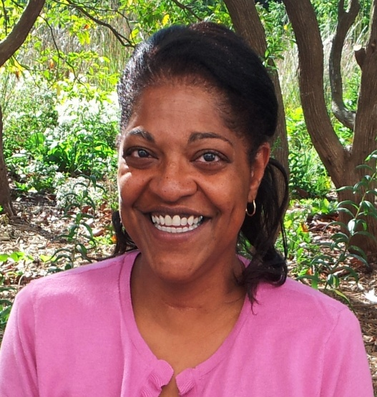What a marvelously momentous year 2013 was for STEPS. It was a year punctuated by transformations, challenges and growth interwoven with unquestionable reward. As many of you know, with growth and increased demand for our services, I came to the realization that without significant organizational changes I could not focus my attention on the executive responsibilities of promoting STEPS, forging collaborations, perpetuating our vision and assuring future sustainability. Thus, a Lead Facilitator was hired to oversee all programming, a college intern was contracted to help STEPS positively engage the social media and Fundraising and Finance Committees were established to research, strategize and execute innovative ways to raise funds and manage those funds.

Throughout the year our girls were a source of absolute joy and reward. Many girls struggle through the emotional, physical and social dynamics of adolescence and our girls are no different. However, our girls demonstrate that regardless of circumstances you can be victorious in these maturation struggles. They are rapidly becoming role models in their schools and community; many receiving academic honors. They are aspiring to and attending college and have become good citizens aware of their self-worth and potential. It is an honor for STEPS and I to participate and assist in this process. I cannot quantify enough the reward and joy these accomplishments have rendered.

I invite you to read the following pages of this report to learn more about the work of STEPS that you so kindly make possible - - - ***empowering the total girl.***

Thank you so much for all you do for the girls of STEPS.

With Sincere Appreciation and Gratitude,

Beatrice L. Jennette

President

# Our Mission

STEPS’ mission is to provide women and girls the tools necessary to build a life of integrity and self-sufficiency through the empowerment of positive choice.

**OUR PROGRAMS**

**Striving 4 Positive Life Choices**

Middle School Program

Builds self-worth, self-esteem, self-awareness, and self-reliance. Utilizing facilitated, interactive workshops to enhance cognitive skills and equip to make informed decisions.

**Project 4 Success & Ready 4 the World**

High School Program

Assist in setting personal, academic and behavioral goals. Focus on team building, leadership skills, community service, job readiness training, college preparation and lifeskills.

**Summer Seminar 4 Leadership Development**

Continues momentum of academic year program, focusing on interpersonal development and team dynamics.

Gender, race, socioeconomic status, ethnicity and the absence of positive role models are often deemed to be limiting factors in the shaping of one’s future aspirations. The empowerment programs of STEPS were designed to combat these factors through education, exposure, equipping and mentorship.

In 2013 STEPS’ first high school graduate Allison Opol was accepted at and is currently attending the University of Connecticut Avery Point. In her own words: “I wouldn’t be a freshman at UConn without the help of many people including STEPS. I joined STEPS during my sophomore year of high school and they have been there for all the academic and personal help that I needed. STEPS provided successful women to come together and help guide young women to achieve more than we believed to be possible. I look at the women of STEPS as family; they have taught me to discipline myself and helped me gain confidence in myself… Without STEPS, I wouldn’t have the goals to become a college graduate and successful in life.”

*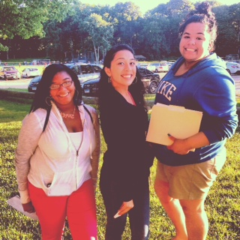From left to right:*

*Royal, high school*

*senior, 8th in her class*

*and college aspirant;*

*Allison, our 1st high*

*school graduate to go*

*to college; and Shareah,*

*high school senior, who*

*is a member of the*

*National Society of High*

*School Scholars.*

# Program Partnerships

The staff and Board of Directors work tirelessly to fulfill STEPS’ mission; however, our success would not be possible without program partnerships and community collaborations.

***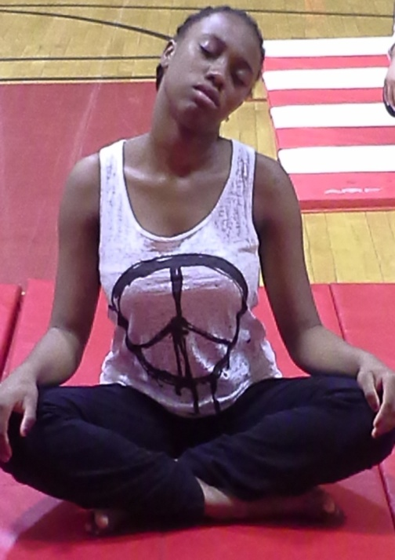***

STEPS has successfully fostered and continues to nurture a relationship with the teachers and administration of the schools in which we serve. It is those partnerships and parental involvements that remain a cornerstone to STEPS’ success.

Laura Quashnie, a participating middle school teacher writes: “For the past five years, the STEPS program has been offered to my students once a week after school. For several of those years, I have hosted the program in my classroom and have been present to watch the majority of the sessions. The girls are engaged in a phenomenal program that teaches them about the real-life issues they face each and every day. The girls learn about anger and stress management, body image, healthy relationships and more. Most importantly, the girls have a safe place where they can talk about the concerns in their lives to caring adults.

Adolescence is such a difficult time in a young person’s life. There are so many choices to make and so many pressures to face. It is far too easy for girls to get off track and make poor choices along the way to adulthood. The women of STEPS guide them along the way.”

Through collaborations our girls are delving into science, technology, engineering, arts, math, health and wellness, college prep, zumba, yoga . . .

*Angelique was relaxing during a yoga session as part of a Stress Management Workshop*

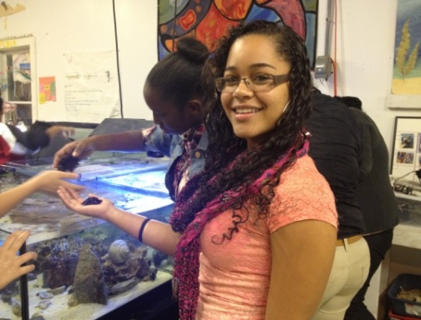

*Twylah enjoyed touching local sea creatures at New England Science and Sailing in Stonington, CT*

# Stepping into Summer

To maintain program continuity and enrich our girls’ summer, STEPS engages in a vibrant and dynamic Summer Leadership Program.

***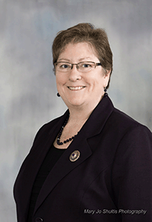***Our Summer Leadership Program was opened by the Honorable Dr. Marian Galbraith, Mayor of the City of Groton. Her presence as a woman in leadership was inspiring enough; however, her speech and subsequent conversation with the girls made for an unforgettable experience.

**Summer Leadership Program**

Meeting for 2 consecutive weeks, the girls were challenged with the following:

* Evening with the Mayor
* Self – Awareness
* Character Building
* The Art of Listening
* Manners and Etiquette
* The Art of Negotiation
* Time Management
* Conflict Resolution

The girls engaged in community service opportunities.

Program concluded with a field trip to the Pinegrove Dude Ranch in Kerhonkson, NY.

The thought that resonated was that leadership was not defined by notoriety, but that a leader was someone who inspired people to make a positive change. She concluded by telling the girls, “Do what you can to make the world a better place and you will be a leader.”

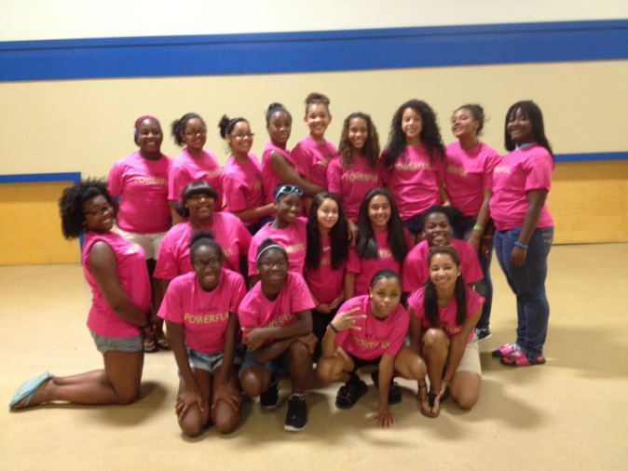

***Participants of STEPS’ 2013 Summer Leadership Program***



|  |  |
| --- | --- |
| IMG_3299.JPG | ***STEPS, INC. 2013 Summer Leadership Program Manners & Etiquette Workshop***  ***Municipal Building***  ***Groton, CT*** |
| ***STEPS, INC. 2013 Summer Leadership Program Community Service at the Garde Arts Center***  ***New London, CT*** | IMG_3221.JPG |
| `Description: C:\Users\Eric\AppData\Local\Microsoft\Windows\Temporary Internet Files\Content.IE5\8QJ55J4D\weeding_garden_at_riverfront.jpg | ***STEPS, INC. 2013 Summer Leadership Program Community Service at Riverfront Children’s Center***  ***Groton, CT*** |

# A Trip to the Ranch

It has been said that being out of one’s element in and of itself is a learning experience. So true!!!

|  |  |  |
| --- | --- | --- |
| Description: D:\IMG_3374.JPG | Description: D:\IMG_3492.JPG | Description: D:\IMG_3500.JPG |

Typically, home represents a comfort zone. Being away from home, the girls had to learn to really trust and depend on one another. Through participating in the various activities at the Ranch, the girls were able to strengthen their bond and really develop a sense of teamwork. The girls looked out for one another, ventured out in teams and developed healthy and meaningful interpersonal dynamics. As the following pictures attest - - the girls had an amazing time.

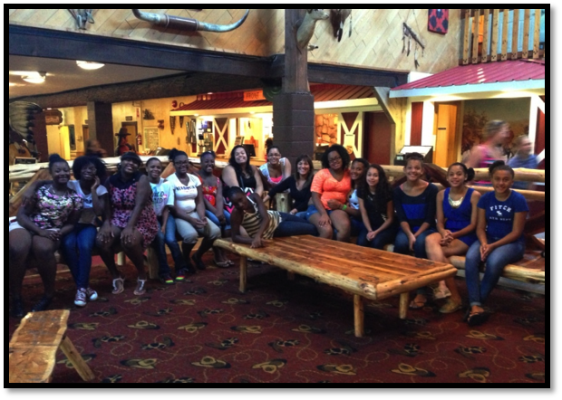

***Pinegrove Dude Ranch***

*30 Cherrytown Road*

*Kerhonkson, NY*

|  |  |
| --- | --- |
| D:\IMG_3463.JPG | **Being away from home the girls had to learn to depend on one another, they ventured out in teams and developed healthy and helpful interpersonal dynamics.**  **The girls were from different neighborhoods and several new friendships were developed.**  **Being away from home often affords opportunities to be reflective. Many of the girls took advantage of this and returned home re-energized, refreshed and revitalized. Exposure to something new initiates imaginations. It is so important not to put limits on possibilities.** |

|  |  |
| --- | --- |
| **Few things better signify the gap in generations and cultures than musical preferences. Chaperones and staff struggled relating to the girls’ music and the girls had difficulty relating to the music played at the ranch. A sense of tolerance had to be developed and the lessons learned in workshops were employed.** | D:\IMG_3412.JPG |

# With Gratitude and Sincere Appreciation

*STEPS extends our deepest thanks to every individual, business*

*and organization that made donations in ﬁscal year 2013:* ***you are, each and every one, our heroes****. Large or small, every gift - financial and in-kind - directly beneﬁts our work to help mentor and empower the young ladies in our community.*

*Below, we oﬀer special recognition to those who financially donated to STEPS during the past fiscal year. We apologize in advance for any inadvertent omissions. Please contact us at 860-941-7949 so that we can rectify any such error.*

Chamber of Commerce of Eastern Connecticut Foundation

Charter Oak Credit Union – Community Grants Program

Chelsea Groton Foundation

City of New London - Community Development Block Grant

The Community Foundation of Eastern Connecticut

Frank Loomis Palmer Fund

Liberty Bank Foundation

Mystic Woman’s Club

Waterford Hotel Group

William Caspar Graustein Memorial Fund

# Board of Directors

**Beatrice Jennette**

**(President)**

**Vivian Harrison**

**(Vice President)**

**Beverly Gonzalez**

**(Treasurer)**

**Jessica Bessette**

**(Secretary)**

**Danielle Cohen**

**(Director)**

**Deborah Evans**

**(Director)**

**Laura Edelstein**

**(Director)**

**Abby Rollins**

**(Director)**

****

# Poised for the Future!!!

In order for STEPS to remain relevant and sustainable within the community that we serve, we will continue to:

* Increase the community’s awareness of STEPS.
* Continue to seek and establish collaborative relationships with other organizations.
* Expand the number of schools we support; thus, increasing the number of students we impact.
* Continuously develop the staff.
* Respond to the community’s needs to the best of our abilities.

STEPS appreciates all the continued support and will always endeavor to be the most efficient and productive recipient of your beneficence.

# Statement of Activities

|  |  |  |
| --- | --- | --- |
| **INCOME** |  |  |
|  | FOUNDATIONS AND GRANTS | $ 15,800 |
|  | TOTAL DIRECT PUBLIC SUPPORT (DONATIONS) | $ 1,294 |
|  | TOTAL INDIRECT PUBLIC SUPPORT | $ 926 |
|  | PROGRAM INCOME  TOTAL FUNDRAISERS | $ 1,606  $ 3,127 |
|  | SPECIAL EVENT | $ 195 |
|  | CONTRIBUTIONS  COSTS OF GOODS SOLD | $ 5,436 |
| **TOTAL INCOME** |  | **$ 28,384** |
|  |  |  |
|  |  |  |
| **EXPENSE** | BUSINESS EXPENSE | $ 89 |
|  | ADMINISTRATION FEES | $ 2,356 |
|  | FUNDRAISING FEES | $ 5,511 |
|  | CONTRACTED SERVICES | $ 1,660 |
|  | PROFESSIONAL FEES | $ 11,958 |
|  | TOTAL FACILITIES AND EQUIP. | $ 277 |
|  | OPERATIONS | $ 3,512 |
|  | OTHER EXPENSES | $ 4,473 |
|  | TRAVEL, MEETINGS AND  RELATED EXPENSES | $ 6,367 |

|  |  |  |
| --- | --- | --- |
| **TOTAL EXPENSES** |  | **$ 36,203** |

**